**Abstract Geometric Metal Wall Art**

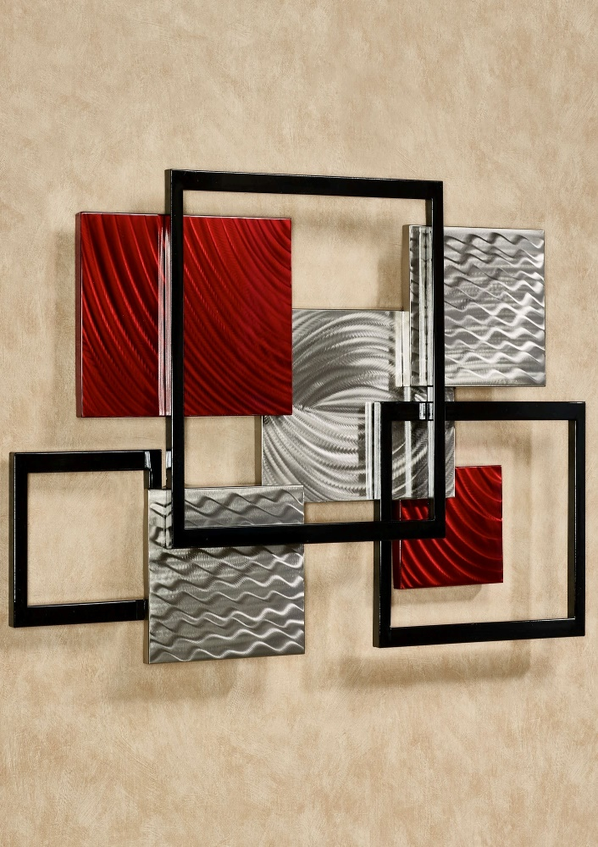Abstract geometric metal wall art is a visually captivating and contemporary decor piece that combines modern design with the industrial beauty of metal. Featuring a variety of geometric shapes—such as triangles, squares, and hexagons—these artworks create dynamic compositions that evoke movement, balance, and structure. The metal construction adds depth and texture, often with a mix of polished, matte, or brushed finishes, while the abstract nature of the design invites personal interpretation. Ideal for modern living rooms, offices, or hallways, abstract geometric metal wall art serves as a striking focal point, adding sophistication and intrigue to any space. Its clean lines and geometric precision make it a versatile piece that complements a variety of interior styles.